**SUBMISSION TO THE PARLIAMENTARY FINANCE AND EXPENDITURE SELECT COMMITTEE REGARDING THE USE OF CHEQUES.**

**AND IN SUPPORT OF PETITION NO:-2017/574 FROM ANDREW BAYLY, MP, THAT GOVERNMENT AGENCIES, SUCH AS THE IRD AND ACC, BE REQUIRED TO ACCEPT CHEQUES AS LEGAL TENDER FOR PAYMENT OF TAXES AND SERVICES.**

This submission is from Dyslexia Foundation of New Zealand (DFNZ). We are happy to appear before the Committee to speak to our submission should this be required.

**SUBMISSION:**

DFNZ was formed in November 2006 and advocates for the estimated one in ten New Zealanders with dyslexia, as well as other neuro-differences that impact brain processing, cognitive understanding and ultimately – when they are not supported appropriately – mental health and self-esteem.

We submit that the Inland Revenue Department (IRD) decision to stop accepting cheques as payment disadvantages and disenfranchises a wide range of people, from those with neuro-differences through to those with disabilities, the older population and people who are sight-impaired.

We submit that Government agencies, such as the IRD, ACC and Kiwibank, be required to accept cheques as legal tender for payment of taxes and services. And that the Finance and Expenditure Select Committee undertake an inquiry to assess whether Government agencies and entities, including IRD, ACC and KiwiBank, have and will put in place adequate provisions to allow those people who are not able to, cannot afford to, or it is not safe for them as members of the public to access government services electronically.

Denying people the ability to make payments by cheque removes a fundamental human right to equitably access goods and services. Issues of financial independence, privacy, convenience and mental wellbeing arise with this denial. Further, if Government departments lead in removing the ability to pay by cheque, banks will quickly follow suit. Highly profitable banks continue to implement aggressive cost-cutting measures, and the removal of cheques is one that will further disadvantage and disenfranchise customers.

It is beyond ironic that Government departments are entertaining this move at the same time the Government is rapidly progressing new accessibility legislation that will introduce enforceable standards for accessibility for all New Zealanders across all areas of life, from education to workplaces, the built environment including public transport through to social inclusion and leisure, tourism and hospitality, goods and services and digital spaces.

We submit it is unfair to penalise people who do not have access to digital banking OR do not feel comfortable using digital banking for a range of valid reasons. For many with neuro-differences, the prospect of digital banking induces high stress, and the prospect of severe financial consequences in making a mistake. Issues that arise with digital banking services include, but are not limited to:

* Financial independence/infringement of privacy: People who require help to navigate online banking services face disclosure of private financial details to those who are helping them. In this there is also potential for said ‘helpers’ to take advantage of this financial information
* Lack of convenience: For many people it is way simpler to write a cheque than navigate digital services, particularly for those who do not have a computer at home or have easy access to one
* In addition, using a computer in a public place, for example a library, also exposes them to financial risk from people who may see the information being input on screen
* Stress and anxiety: For those with neuro-difference, using online banking services is a highly stressful process, with fear of inputting wrong information or pushing the wrong button leading to financial loss
* Neurotypical process does not allow for difference: Operating in a linear executive style function, which is required with online banking, is not a strength for those with neuro-differences. Put yourself in the shoes of someone with dyscalculia – where numbers transpose – and imagine the stress of making a payment of ‘$6942’ when you intended to input $2469’. Understandably many people in this position feel safer and more in control writing a cheque than dealing with disorientation online
* Mental health: Failing in navigating this process only adds to feelings of vulnerability, lack of confidence and low self-esteem
* Vulnerability to scams. Internet scams are increasingly common. One of the propensities for some people with neuro-differences is to say ‘yes’ to questions as a coping mechanism in order to seem affable, portray confidence and/or simply make questions go away. This propensity makes these people overly vulnerable to internet and online banking scams

Overall, any moves to stop accepting cheques can be seen as short-sighted, penny pinching and deeply concerning in the infringement of fundamental human rights. Whilst this issue may seem of little consequence to those who are ‘digital natives’ it is of deep concern to a wide cross-section of society.

DFNZ asks that the Finance and Expenditure Select Committee consider this issue very carefully and act urgently to ensure, as outlined above, that Government agencies, such as the IRD, ACC and Kiwibank, be required to accept cheques as legal tender for payment of taxes and services.

And that the Finance and Expenditure Select Committee undertake an inquiry to assess whether Government agencies and entities, including IRD, ACC and KiwiBank, have and will put in place adequate provisions to allow those people who are not able to, cannot afford to, or it is not safe for them as members of the public to access government services electronically.

Kind regards

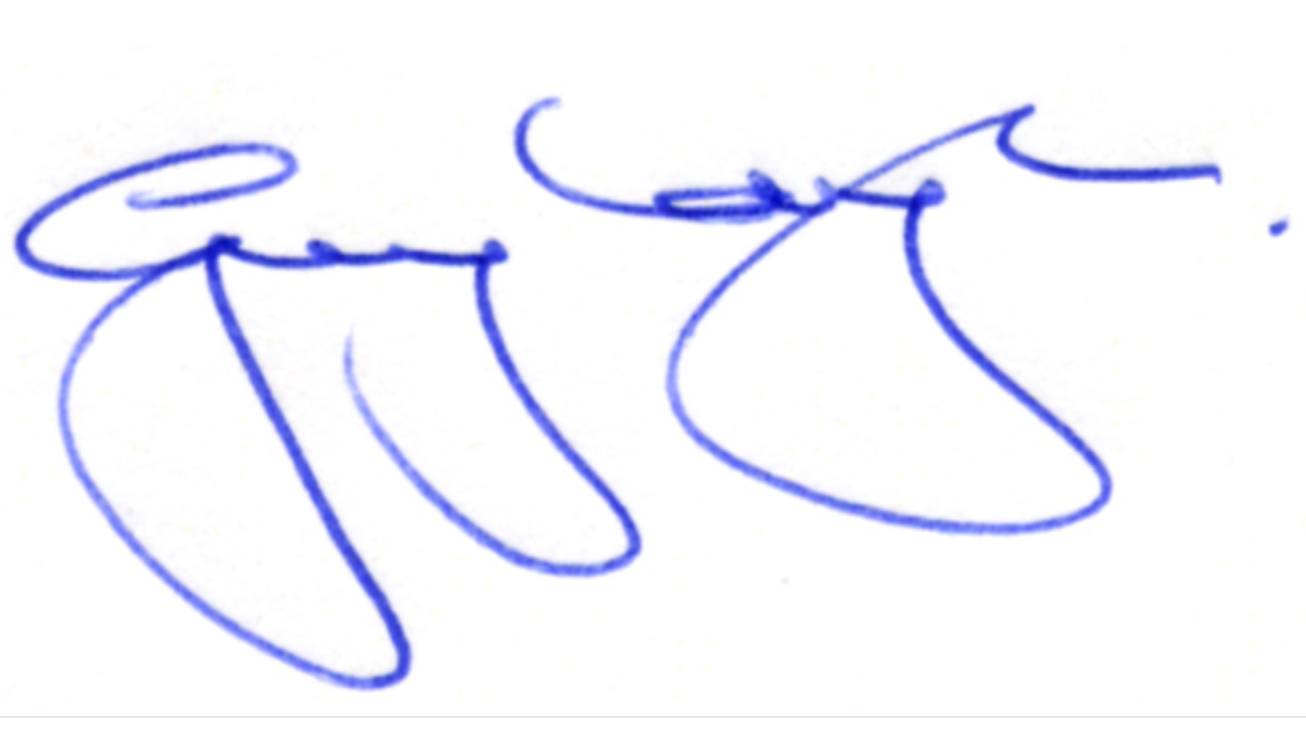

Guy Pope-Mayell

Chair of Trustees

Dyslexia Foundation of New Zealand